**Step 1 − Verify Node and Npm Versions**

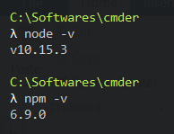

**Step 2 − Create a Project Folder and Open in VSCode**

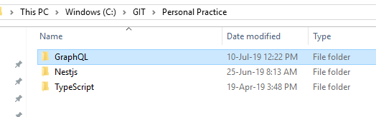

**Step 3 − Create package.json and Install the Dependencies**

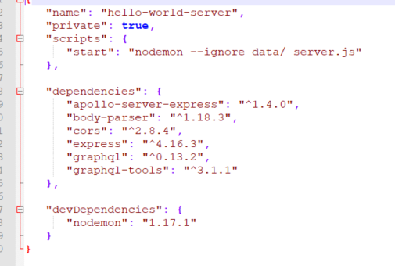

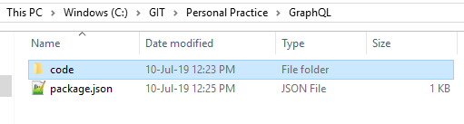

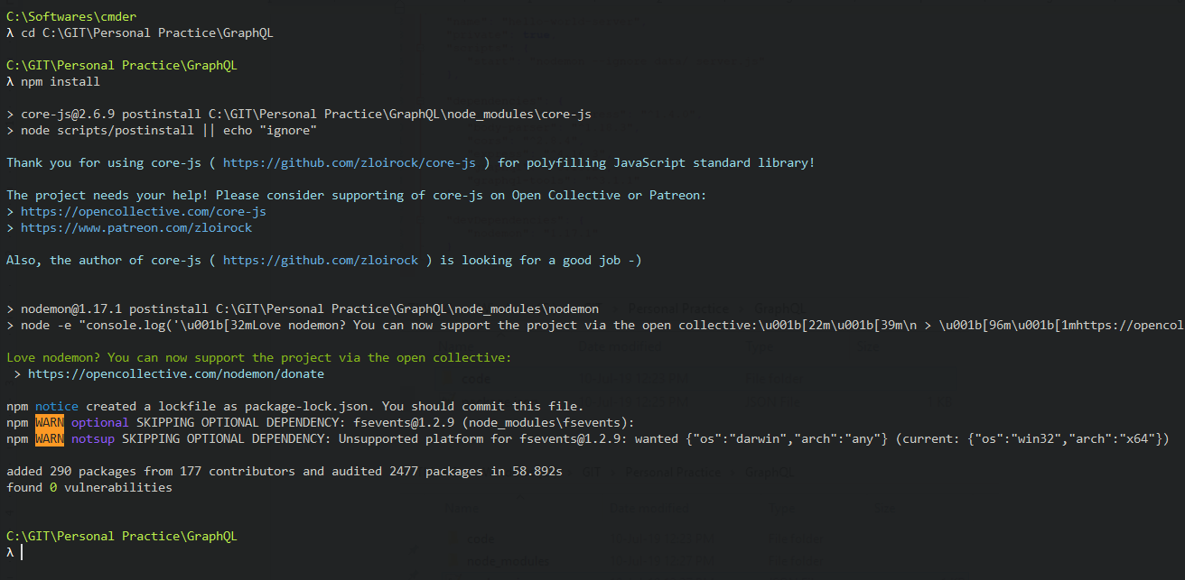

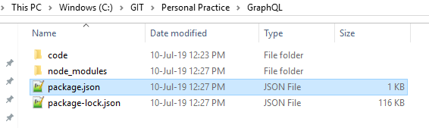

**Step 4 − Create Flat File Database in Data Folder**

we use flat files to store and retrieve data. Create a folder data and add two files **students.json** and **colleges.json**.

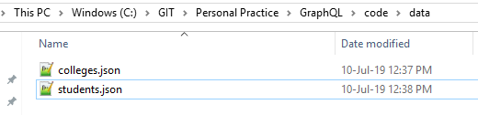

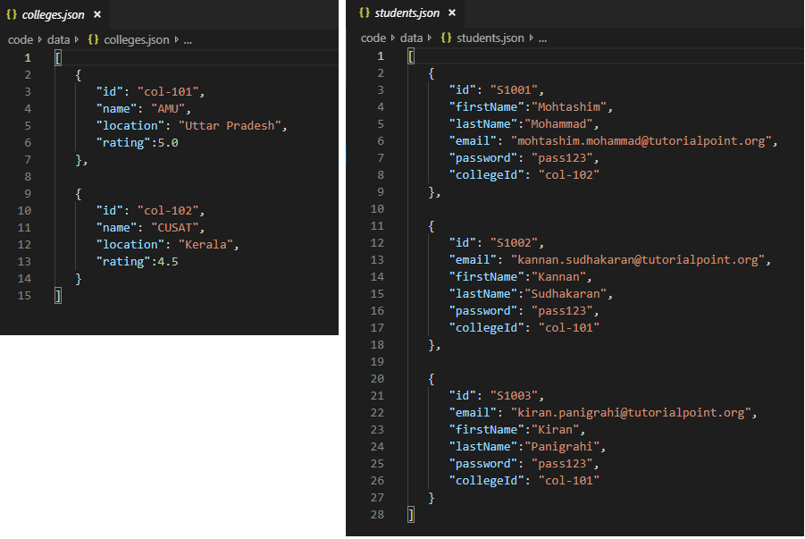

**Step 5 − Create a Data Access Layer**

We need to create a datastore that loads the data folder contents.

In this case, we need collection variables, *students* and *colleges*.

Whenever the application needs data, it makes use of these collection variables.

Create file db.js with in the project folder as follows

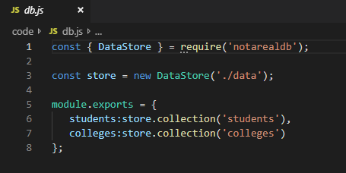

**Step 6 − Create Schema File, schema.graphql**

Create a schema file in the current project folder and add the following contents

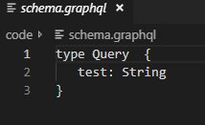

**Step 7 − Create Resolver File, resolvers.js**

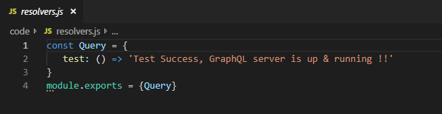

**Step 8 − Create Server.js and Configure GraphQL**

Create a server file and configure GraphQL as follows

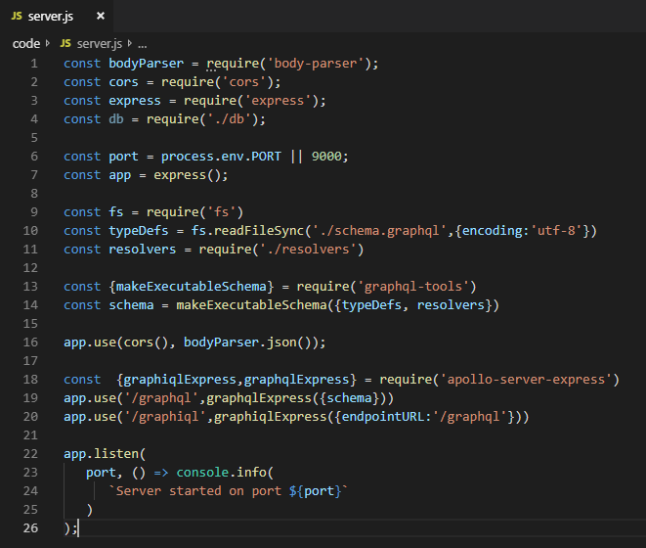

**Step 9 − Run the Application and Test with GraphiQL**

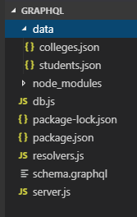

Run the command npm start

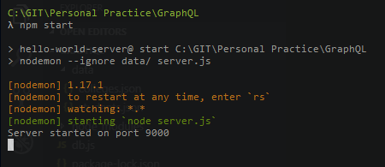

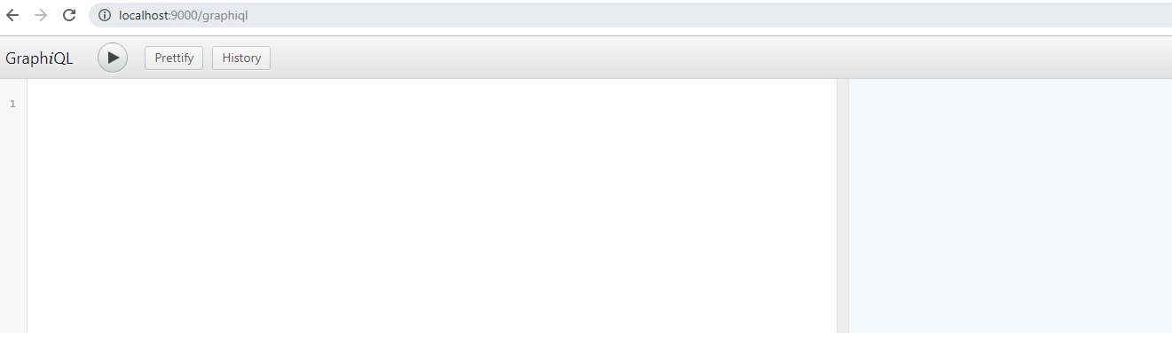

Now we test the new application

